The Ongoing Mystery of The Hubble Tension
A Dark Matter

From Across Time

Edward Pigott (1785)

John Goodricke (1786)

Henrieta Swan Leavitt (1908)

The Manhattan Project (WW II)

The Hubble Space Telescope (2022)

The James Webb Space Telescope (2024)
The First Einstein Zig-Zag Lens (2024)
A Path to New Physics?
Or Just a Bubble?

Alex Alaniz, PhD

19 December 2024

Executive Summary
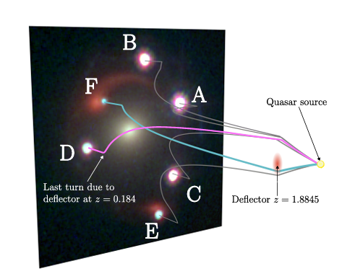
Found in 2024: first Einstein zig-zag lens. A quasar’s light is lensed by a strong gravitational lens (a galaxy) and is bent around several paths towards Earth producing multiple images. Other paths get lensed by a second lens (second galaxy) leading to more images of the quasar and the first galaxy. This lens may settle the “Hubble Tension”. Images $D$ (quasar) and $F$ (first galaxy) below are the zig-zag images (see Dex et al, 2024 cited later).
Hubble Tension is a discrepancy of the universe's expansion rate given by$H_{o}$ (Hubble constant). Three independent methods at different length scales conflict. Using three types of standard candles in 2024, James Webb Space Telescope (JWST) bracketed the local rate to $H_{o}=72.6 ±2.0$km/s/Mpc, verifying Hubble Space Telescope (HST): $H_{o}=73.2 ±0.9$km/s/Mpc (a megaparsec or 3.262 light years), significantly different from the Cosmic Microwave Background (CMB) method: $H_{0}=68.62 ±0.52$ km/s/Mpc.

This work explains the astrophysics of local, intermediate, and cosmic scale methods for measuring $H_{0}$ including limiting factors. It covers a story beginning in 1784 with the discovery of the first two Cepheid variable stars. These stars have predictable pulsation-luminosity dynamics, as first discovered in 1908. This work ends with the arXiv preprint of “J1721+8842: The first Einstein zig-zag lens”, F. Dux et al, 6 Nov 2024, arXiv:2411.04177v1.

A Hubble superbubble might lead to a higher local $H_{0}$ Perhaps time dilation (tens of percent slower time rates in galaxies than in voids) could explain away dark energy. If the Hubble Tension is irresolvable, new physics is indicated. We are living in exciting times.
Contents
Executive Summary i
Setting the Stage, A Quick Background 1
Local Methods: Cepheid and Type 1a Supernovae as Standard Candles 1
Cepheid variables 1
Type 1a Supernovae explosions (Sne 1a) 2
Mid-Scale Methods 2
Cosmic Scale Methods: The Cosmic Microwave Background (CMB) Method 3
Opacity Prerequisites 3
Physical Mechanisms of Opacity 4
Opacity in Stellar Physics 4
Rosseland Mean Opacity 5
Astrophysical Applications of Opacity 5
Opacity (the Eddington $κ$ Mechanism in Cepheid Variables) 5
Using Cepheid Variables as Standard Candles 6
Refinements and challenges 6
Maximum Range using Cepheid Variables 6
Relation to the Cosmic Distance Ladder 7
Sne 1a As Secondary Standard Candles 7
Sne 1a Physics 8
White Dwarfs 8
Under Pressure 8
How Pressure Works in Ordinary Matter vs. Degenerate Matter 9
Pressure in Degenerate Matter 9
Why Can't Degenerate Matter Expand and Cool? 9
The Consequences for the White Dwarf in a Binary System: Boom 9
Distance Limits of Type 1a 9
Intrinsic Brightness of Type Ia Supernovae 9
Current Observational Limits 10
Factors Limiting the Maximum Distance 10
Applications and Utility 10
Limits of the human eye in redshift z for various astrophysical phenomenology 10
Measuring the Hubble Constant, $Ho$ with Cepheids and Sne1 11
Intermediate Distances: Strong and Weak Gravitational Lensing 12
Strong lensing 12
Weak Lensing 13
Observational Applications of Strong Gravitational Lensing : Time-delay Cosmography 15
Concept of Gravitational Lensing and Time Delay 15
Two Reasons for Time Delays 15
Time-Delay Distance $DΔt$ 16
Steps to Determine $Ho$ 16
5. Advantages of Time-Delay Cosmography 16
6. Challenges and Systematics 16
7. Recent Results 17
8. Resolving the Hubble Tension 17
Summary 17
Einstein zig-zag lens (first one found in 2024) 17
Observational applications of Weak gravitational lensing 19
Dark Matter EOS improvements for better measurements of $Ho$ and better understaning of dark matter 19
General Form of the Equation of State 19
Why $w≈0$? 19
Implications of the EOS for Dark Matter 20
Alternative EOS for Dark Matter 20
Comparison with Dark Energy 20
The Cosmic Scale Rung of the Cosmic Distance Ladder – the Cosmic Microwave Background (CMB) 20
Angular Power Spectrum of the CMB 21
Physics of the Acoustic Peaks 21
How $H0$ is Measured: 21
Degeneracies and Constraints: 21
Role of Inflation and Initial Conditions: 22
Current Tensions: 22
What Causes the Hubble Tension? 22
Appendix A: Sample Rosseland Opacity Calculation 23
Appendix B: Cepheid Variable Luminosity in More Detail 25
Ionization Zones in the Stellar Envelope 25
The κ Mechanism (Eddington Valve) 25
Thermonuclear Energy and Stability 26
Mass, Radius, Temperature, and Luminosity Periodicity 26
Thermodynamics of the Envelope 26
Interaction with the Thermonuclear Core 27
Appendix C: The Hertzsprung-Russel Diagram 28
Axes of the Diagram 28
Main Features of the Diagram 29
How Stars Evolve on the H-R Diagram 29
Applications of the H-R Diagram 30
Simplified Example 30
Summary 31
Appendix D: All Supernova Types 32
1. Core-Collapse Supernovae (Massive Stars) 32
2. Thermonuclear Supernovae (White Dwarfs) 32
3. Rare and Exotic Supernovae 33
4. Summary of Supernova Types 34
Appendix E: Observational Limits in terms of Redshifts, $z$ 35
Hubble Versus James Webb Space Telescope 35

Table of Figures
Figure 1 Strong Lensing (Wikipedia attribution) 12
Figure 2 Weak (statistical) lensing (Michael Schs Wikipedia Commons) 13
Figure 3 Averaging of 'shape noise' of galaxies (Wikipedia) 14
Figure 4 The first zig-zag lens 18
Figure 5 Herzsprung-Russel Diagram 28

Setting the Stage, A Quick Background
The "Hubble tension" refers to a discrepancy of the universe's expansion rate characterized by the Hubble constant, $H_{o}$, where three fundamentally independent methods (at three different length scales) produce conflicting results. In late 2024, using three types of standard candles, the James Webb Space Telescope (JWST) bracketed the expansion parameter to $H_{o}=72.6 ±2.0$km/s/Mpc, verifying the results from the Hubble Space Telescope (HST) giving $H_{o}=73.2 ±0.9$km/s/Mpc. Mpc stands for megaparsec, where a parsec is 3.262 light years.

These two independent local neighborhood scale measurements are in tension with Big Bang cosmic microwave (CMB) scale methods that peg the expansion $H_{o}$, depending on some combination of five independent data sets at $68.86 ±0.68$ km/s/Mpc, $68.72 ±0.51$ km/s/Mpc, and $68.62 ±0.52$ km/s/Mpc, with significance levels of 3.4$σ$, 3.7$σ$, and 3.8$σ$, respectively. In terms of standard deviation, $σ$, the statistical differences between local and cosmological scale methods are in significant disagreement.

For reference the biggest redshift observed by JWST is 14.32 (197 billion light-years).

Local Methods: Cepheid and Type 1a Supernovae as Standard Candles

Cepheid variables
A Cepheid variable is a type of variable star that pulsates radially, varying in both diameter and temperature. It changes in brightness, with a well-defined stable period and amplitude. Cepheids are important cosmic benchmarks (a species of standard candle) for scaling galactic and extragalactic distances.

On September 10, 1784, Edward Pigott detected the variability of Eta Aquilae, the first known representative of the class of classical Cepheid variables. The eponymous star for classical Cepheids, Delta Cephei, was discovered to be variable by John Goodricke a few months later. The number of similar, classical variables grew to several dozen by the end of the 19th century. Cepheids include Type II Cepheids, which are older, fainter, with lower metallicity, and the RV Tauri stars, a subtype of Type II Cepheids, but with alternating deep and shallow brightness minima.

A relationship between the period and luminosity (P-L) for classical Cepheids was discovered in 1908 by Henrietta Swan Leavitt in an investigation of thousands of variable stars in the Magellanic Clouds. Her discovery establishes the true luminosity of a Cepheid by observing its pulsation period. The P-L relationship in turn gives the distance to a Cepheid variable by comparing its known luminosity to its observed brightness, calibrated by parallax to the closest Cepheids such as RS Puppis and Polaris.

In 1913, Ejnar Hertzsprung made initial attempts to determine distances to Cepheids using statistical methods, but direct parallax measurements were limited by the technology of the time. More recently, the Hipparcos satellite (1989), HST, and the Gaia Mission, launched in 2013, have refined the parallax method for Cepheid variables and other standard candles, e.g., Type 1a supernovae explosions (Sne 1a).

Cepheid variability is driven by an interplay between gravity, thermodynamics, and opacity, a measure of the ease or difficulty of radiation transport through plasmas at various pressures, temperatures, and densities, e.g., stellar atmospheres, inner thermonuclear stellar structure, thermonuclear weapons, and experimental thermonuclear reactors such as tokomaks and stellarators.

Type 1a Supernovae explosions (Sne 1a)
Sne 1a, when they occur near Cepheid variables, extend the range of cosmic distance measurements because they are far brighter than Cepheid variables. Rapid onset coupled thermonuclear opacity processes drive Sne 1a explosions. All Sne 1a, as will be explained in a latter section, are, effectively, identical in nature.

Improvements in the theory and computation methods of coupled radiation hydrodynamics methods (later as computer codes) matured by World War II (WWII) Manhattan Project atomic bomb physicists have honed the use of both Cepheid variables and Sne 1a as local scale standard candles.

Mid-Scale Methods
The phenomenology of general relativistic lensing (the bending of light by galaxies turned into gravitational lenses) extends the applicable range of Cepheid variables, Sne 1a, and the other standard candles. The implications of this phenomenology, including the first discovery of a compound (two galaxy) Einstein zig-zag lens by JWST in 2024, on intermediate distance measurements, will be treated further ahead, as well as the implications of the zig-zag lens on dark matter theories.

Cosmic Scale Methods: The Cosmic Microwave Background (CMB) Method
Astronomers analyze the temperature fluctuations and angular scale of the CMB radiation to measure the Hubble constant. The CMB provides information about the geometry and expansion rate of the universe, allowing indirect calculation of the Hubble constant within the framework of a cosmological model like the Lambda Cold Dark Matter (or $ΛCDM$) by fitting the observed CMB data to the model's predictions; essentially, the CMB acts as a snapshot of the early universe, providing crucial constraints on the expansion rate.

Opacity Prerequisites
In the 1920s, Arthur Eddington advanced the understanding of energy transport in stars, emphasizing radiative transfer and the role of opacity in determining stellar structure. The kappa, $κ$, opacity mechanism (or the Eddington $κ$ valve) explains the physics behind the changes in luminosity of many types of pulsating variable stars including Cepheid variables in terms of coupled thermodynamic and radiation transport processes in the outer helium layers of Cepheid variables.

While opacity theory predates Svein Rosseland, this astrophysicist played a significant role in formalizing and applying it, particularly in the context of radiative energy transport in stars. His major contribution came in the 1920s and 1930s, providing astrophysics with a systematic, quantitative framework for calculating opacity in stellar interiors. Rosseland's opacity methods allowed astronomers to model energy transport in stars with complex compositions and temperature gradients, greatly improving models of stellar evolution.

Building on Rosseland’s work, WWII Manhattan Project atomic bomb physicists developed more advanced computational tools which later evolved into modern radiation hydrodynamics transport codes used in nuclear physics, astrophysics, and thermonuclear research.

In astrophysics, opacity refers to the measure of how resistant a material is to the passage of radiation, such as light, X-rays, or other electromagnetic waves. It is a fundamental property in stellar physics, governing how energy is transported through a star and influencing phenomena like the pulsations of Cepheid variables.

Opacity, $κ$, quantifies the ability of matter to absorb or scatter radiation. It is the opposite of transparency. With high opacity, radiation struggles to pass through; the material absorbs or scatters most of the energy. With low opacity, radiation passes through more easily.

Mathematically, opacity is defined as the cross-sectional area for absorption and scattering per unit mass:

$$κ=\frac{α}{ρ} \left[\frac{cm^{2}}{g}\right].$$
where:
- $α$ is the absorption coefficient (cross-sectional area per unit volume), and
- $ρ$ is the density of the material in g per $cm^{3}$.

Physical Mechanisms of Opacity
Opacity arises from interactions between photons and matter. Different physical processes contribute to opacity depending on the temperature, density, and composition of the material. There are:

Bound-Bound Transitions: Electrons bound to atoms or ions absorb photons at specific wavelengths to move to higher energy levels. An example is hydrogen absorption lines in stellar spectra.

Bound-Free Transitions (Photoionization): A photon is absorbed, providing enough energy to free an electron from an atom or ion. An example is hydrogen photoionization, which contributes significantly to the opacity in stars like the Sun.

Free-Free Transitions (Bremsstrahlung): A free electron interacts with an ion, absorbing or emitting energy without being captured. This process dominates in high-temperature plasmas.

Electron Scattering: Photons scatter off free electrons, changing direction but not energy (in non-relativistic cases). In very hot stars, this is the primary source of opacity.

Molecular Absorption: At lower temperatures, molecules can absorb photons at specific wavelength, e.g., water vapor and carbon monoxide absorption in cooler stars.

Opacity in Partially Ionized Zones ($κ$ Mechanism): In partially ionized gases, the presence of bound electrons allows for temporary absorption and re-radiation of energy, crucial for driving stellar pulsations like those observed in Cepheid variables.

Opacity in Stellar Physics
Opacity is a critical factor in the transport of energy through a star, which can occur via radiation or convection. Radiation dominates in hot stars; photons carry energy outward. Convection dominates in cooler regions where opacity is high; energy is carried by the bulk motion of material.
The interplay between radiative and convective modes of energy transport depends on the opacity. For high opacity, energy transport slows, and convection becomes dominant. For low opacity, radiation can carry energy more efficiently.

Rosseland Mean Opacity
In stellar physics opacity varies with wavelength. The Rosseland mean opacity is used by providing an average opacity weighted by how effectively radiation is transported:
$$\frac{1}{κ_{R}}=\frac{\int_{0}^{∞}{\frac{1}{κ_{ν}}∙\frac{∂B_{ν}}{∂_{t}}}dν}{\int_{0}^{∞}{\frac{∂B_{ν}}{∂T}}dν}$$
where:
$κ_{ν}$: is the opacity at frequency $ν$,
$B_{ν}$: Is the Planck (blackbody radiation) function, and
$T$: Is the temperature.
(Optional) For a simple example see Appendix A: Sample Rosseland Opacity Calculation.

Astrophysical Applications of Opacity
Stellar Structure and Evolution determines how energy transports from the core to the surface.

- Stellar Atmospheres: Shapes spectra and influences temperature gradients.
- Stellar Pulsations: Drives variability in stars like Cepheids, RV Tauri, and RR Lyrae stars, stars that pulsate with large amplitudes often found in globular clusters.
- Cosmology and Early Universe Physics: Opacity affects the release of the Cosmic
Microwave Background radiation during recombination.

Opacity (the Eddington $κ$ Mechanism in Cepheid Variables)
In Cepheid variables, the partial (single electron) ionization of the outer helium layer creates conditions where opacity increases during gravitational compression. As the star’s outer layers are compressed, helium ionizes more so (increasingly doubly ionized), trapping more photons, which heats the layer and increases pressure. The increasing pressure eventually reverses the inward collapse into outer expansion. During expansion, helium recombines, reducing opacity and allowing radiation to escape, lowering the temperature.

This cyclical change in opacity drives the pulsations observed in Cepheid variables that underlie the Henrietta Swan P-L relationship. She noted that longer periods correspond to higher luminosity. See Appendix B: Cepheid Variable Luminosity in More Detail for more physics details of Cepheid variables, including their interaction with the star’s energy producing core (or higher shell if the core has exhausted its thermonuclear fuel: hydrogen).

Using Cepheid Variables as Standard Candles
- Measure the Period: Observe the periodic variation in the star's brightness.
- Determine the Absolute Magnitude ($M$): Using the calibrated P-L relationship, the pulsation period is converted into the star’s absolute magnitude (how bright it would appear at a standard distance of 10 parsecs).
- Measure the Apparent Magnitude ($m$): The apparent brightness of the star as seen from Earth is measured.
- Apply the Distance Modulus: The distance modulus formula relates the absolute magnitude, apparent magnitude, and distance.
$$m-M=\log_{10}{d}-5,$$
$$d=\frac{{10}^{m-M+5}}{5}.$$
The distance, $d$, is the distance to the Cepheid variable.

Cepheids are bright enough to be observed in distant galaxies. On 30 December 1924, Edwin Hubble, using the Hooker 100-inch telescope of the Mount Wilson Observatory, discovered Cepheids in the Andromeda Nebula to ultimately determine that this “nebula” was not part of the Milky Way galaxy, but was its own proper galaxy.

Refinements and challenges
The Eddington $κ$ mechanism of Cepheid variables underpins their highly regular P-L relationships, making Cepheid variables extremely useful as standard candles for determining distances to local celestial objects. Nearby Cepheids are calibrated by parallax methods. The use of modern radiation hydrodynamics transport codes helps calibrate astrophysical Cepheid variable data for improved local scale distance measurements beyond parallax techniques. There are other challenges and refinements, including the following:
- Interstellar Extinction: Dust can dim the light of Cepheids, requiring corrections.
- Metallicity Effects: The P-L relationship can depend slightly on the star’s chemical composition, so adjustments are sometimes needed.
- Population Types: Cepheids are divided into two main types, Classical and Type II, which require different P-L calibrations.

Maximum Range using Cepheid Variables
Classical Cepheids are typically brighter than Type II Cepheids and thus usable at farther distances. The maximum distance for which classical Cepheid variables can be used as standard candles depends on their intrinsic brightness and the observational capabilities of current telescopes. Here's a breakdown of the factors influencing this range:

Intrinsic Brightness of classical Cepheid Variables: Cepheids are luminous stars, with absolute magnitudes ranging from approximately −3.3 to −6.6 in the visual band, V (a passband within the visible light range, 551 nm $±$ 44 nm), and even brighter in the infrared (−6-6 to −8-8). This high luminosity allows them to be observed at great distances.

Current Observational Limits: Using its advanced resolution and sensitivity, HST has observed Cepheids up to distances of about 100 million light-years (roughly 30 megaparsecs (Mpc)) in nearby galaxies. For example, Cepheids have been used to measure distances in galaxies within the Virgo Cluster. The JWST: Operating in the infrared, JWST extends the range because it reduces the effects of interstellar extinction. It is expected to observe Cepheids in galaxies beyond 30 Mpc upwards to 40 Mpc, pushing the limits of their utility.

Practical Limits: While Cepheids are intrinsically bright, their apparent brightness decreases with distance according to the inverse square law. At large distances, several challenges arise. Beyond 30–40 megaparsecs, even Cepheids become too faint for detailed observations with most telescopes. Furthermore, in distant galaxies, it becomes harder to resolve individual Cepheids from other nearby stars due to blending and crowding in dense stellar fields.

Relation to the Cosmic Distance Ladder
Cepheids are not used to measure distances beyond about 100 Mpc (or 0.1 Gpc) because their utility fades at such ranges. Instead, their measurements are used to calibrate more luminous standard candles, such as Type Ia supernovae (Sne 1a), which can be seen at distances of billions of light-years.

Cepheids are valuable for local measurements. Their range, however, is minuscule compared to the vast scale of the observable universe. The observable universe is a sphere 93 billion light years, or 28.5 Gpc in diameter. The next rung up the cosmic ladder, still local, are Type 1a supernovae explosions, (or Sne 1a). For further details on Cepheid variable physics, see Appendix B: Cepheid Variable Luminosity in More Detail.

Sne 1a owe Cepheid variables for their calibration. When an Sne 1a occurs near a Cepheid variable, its distance is tagged. Sne 1a work as standard candles for reasons unique to them. Each Sne 1a is, effectively, identical.

Sne 1a As Secondary Standard Candles
In a nutshell, Sne 1a are triggered by white dwarfs in binary star systems. The dwarfs (with a low rate of rotation) accrete gas from their partner stars until they reach 1.4 solar masses, $M_{⨀}$, triggering an explosive thermonuclear processes. When these occur near Cepheid variables in a more distant galaxy, we calibrate their brightness as a function of distance. Since Sne 1a are far brighter than Cepheid variables, it makes them the second rung of the cosmic distance ladder. Type 1a supernovae became widely recognized as "standard candles" in the late 1980s and early 1990s, primarily due to the work of astronomers like Saul Perlmutter, Adam Riess, and Brian Schmidt who used them to study the expansion rate of the universe and made significant discoveries about dark energy, with their key findings published in 1998

Sne 1a Physics

White Dwarfs
White dwarfs are thought to be the final evolutionary state of stars whose mass is not high enough to become a neutron star or black hole, about 97% of Milky Way stars. After a main sequence star of low or intermediate mass (Appendix C: The Hertzsprung-Russel Diagram) ends its hydrogen-fusing period, it will expand to become a red giant. As a red giant, it will fuse helium to carbon and oxygen in its core by the triple-alpha process. If a red giant has insufficient mass to generate the core temperatures required to fuse carbon (around ${10}^{9}$ K), an inert mass of carbon and oxygen will build up at its center. After such a star sheds its outer layers and forms a planetary nebula, it will leave behind a core, which is the remnant white dwarf. Usually, white dwarfs are composed of carbon and oxygen (a CO white dwarf). If the mass of the progenitor is between 7 and 9 solar masses, $M_{⊙}$, the core temperature will be sufficient to fuse carbon but not neon, in which case an oxygen–neon–magnesium (ONeMg or ONe) white dwarf may form. Stars of very low mass will be unable to fuse helium; hence, a helium white dwarf may form by mass loss in an interacting binary star system. White dwarfs of the CO type underlie Type 1a supernovae explosions (Sne 1a). For a review of all types of supernovas see Appendix D: All Supernova Types.

Under Pressure
To understand Sne 1a, it is necessary to understand degenerate matter. Degenerate matter is a highly compressed state of matter where the pressure is not determined by the usual thermal motion of particles, but rather by the Pauli Exclusion Principle, a fundamental quantum mechanical law. It’s first application was to simple atoms: no two electrons in the same atom can have identical values of all four of their quantum numbers. The two electrons in the ground state orbital of hydrogen, for example, have opposite spins. (This allows for technologies based on nuclear magnetic resonance (NMR), or magnetic resonance imaging (MRI), rather.

More generally, Pauli Exclusion states that no two fermions (like electrons) can occupy the same quantum state simultaneously, whether in an atom or in a white dwarf. In a white dwarf, the atoms of carbon and oxygen are crushed together so tightly that electrons are forced into the smallest possible quantum states. This creates electron degeneracy pressure, which supports the star against gravity.

How Pressure Works in Ordinary Matter vs. Degenerate Matter
In ordinary matter (like in the Sun or Earth's atmosphere), pressure depends on temperature. When a gas heats up, the particles move faster, increasing the pressure. If the gas expands, the particles spread out, cool down, and reduce the pressure. This temperature-pressure relationship allows systems, like Cepheid variables, to respond dynamically to changes, like heating or cooling.

Pressure in Degenerate Matter
In degenerate matter, the pressure is nearly independent of temperature. Instead, it is determined by the density. Electron Degeneracy Pressure arises from the quantum mechanical Pauli exclusion properties of the electrons, which resist being compressed further. This means the white dwarf can sustain itself against gravity even if its temperature is very low, unlike an ordinary gas, which would collapse without thermal pressure.

Why Can't Degenerate Matter Expand and Cool?
In normal matter, if energy is added, e.g., from nuclear fusion, the gas heats up, expands, and cools down as part of a self-regulating process. In degenerate matter, adding energy, e.g., from nuclear fusion, does not lead to significant expansion because the pressure isn’t driven by temperature. Instead, the electrons are already packed into their minimal quantum states, and there’s very little "room" to expand. Most of the energy goes into increasing the temperature, not expansion.

The Consequences for the White Dwarf in a Binary System: Boom
As a member of a binary star system with another main sequence star, a white dwarf will accrete gas from its partner star. As the gas piles atop the CO white dwarf, pressure builds. Carbon fusion ignites in the white dwarf when reaching 1.4 $M_{⨀}$ leading to runaway heating. The fusion process is extremely exothermic, releasing an enormous amount of energy in a very short time. In normal stars, this energy would cause the outer layers to expand, cooling the star and stabilizing the reaction, but in a white dwarf, the degeneracy pressure does not respond to temperature changes, so the heat cannot trigger expansion.

The heat from the carbon fusion raises the temperature further, accelerating the fusion reaction up the periodic table of elements (fusion rates are highly sensitive to temperature). This autocatalytic process leads to an uncontrollable cascade of energy release, culminating in the complete, catastrophic detonation of the white dwarf.

Distance Limits of Type 1a
The maximum distance for using Type Ia supernovae as standard candles depends on their established brightness relative to the capabilities of telescopes. Here's an overview:

Intrinsic Brightness of Type Ia Supernovae
Type Ia supernovae have a peak absolute magnitude of M∼−19.3 in the visible band (BB, 380 – 700 nm) and are brighter in the infrared. They are among the brightest standard candles observable across vast, but local, distances. Accounting for small variations in brightness with the Phillips relation, linking the peak brightness to the rate at which its light curve declines, calibrates the brightness.

Current Observational Limits
The maximum distance depends on how faint a supernova can be detected by a telescope:
- HST: Detects Type Ia supernovae up to z ≈ 1.7, corresponding to a distance of about 10 billion light-years (3 Gpc).
- JWST: With its advanced infrared capabilities, JWST can extend this range slightly, potentially observing SNe Ia up to z ≈ 2, corresponding to about 11 billion light-years (3.3 Gpc).

Factors Limiting the Maximum Distance
The maximum practical distance for Type 1a as standard candles is about 10-11 billion light-years (redshift $z≈2$), depending on the sensitivity of the telescope and the brightness of the supernova. This range covers a significant portion of the observable universe, making Sne 1a vital for cosmology and measuring the Hubble constant.

a) Detection Sensitivity
At high redshifts, supernovae become extremely faint from the usual inverse square law effect (apparent brightness decreases with the square of the distance), and cosmological redshift, shifting light to the infrared and spreading its energy over a wider wavelength range.

b) Interstellar and intergalactic dust can obscure the light, making distant supernovae harder to observe.

c) Calibrations and Systematics. At very high redshifts, differences in metallicity and stellar population ages may introduce subtle variations in SNe Ia properties, affecting their reliability as standard candles.

Applications and Utility
Type Ia supernovae are primarily used to:
- Measure distances up to 10–11 billion light-years.
- Probe the universe's expansion history and discover and characterize phenomena like dark energy and the accelerated expansion of the universe.

Limits of the human eye in redshift z for various astrophysical phenomenology
If interested in limits of astronomy from the human eye onwards see Appendix E: Observational Limits in terms of Redshifts, $z$.

For greater distances, $z>2$, there are alternative probes such as Gamma-ray bursts (GRB) which are brighter and observable at higher redshifts and redshift measurements from the Cosmic Microwave Background (CMB) or large-scale structure studies.

Measuring the Hubble Constant, $H_{o}$ with Cepheids and Sne1
In standard cosmology, comoving distance and proper distance (or physical distance) are closely related distance measures used to define distances between objects. Comoving distance factors out the expansion of the universe, giving a distance that does not change in time except due to local factors, such as the motion of a galaxy within a cluster. Proper distance roughly corresponds to where a distant object would be at a specific moment of cosmological time, which can change over time due to the expansion of the universe. Comoving distance and proper distance are defined to be equal at the present time. At other times, the Universe's expansion results in the proper distance changing, while the comoving distance remains constant.

To measure the Hubble constant, use the distances to galaxies as determined by Cepheids and Sne 1. Combine distances, $d$, and redshifts to derive $H_{o}$ thusly:

1. Measure Redshifts, $z$: In astronomy, the formula for redshift is:
$$z=\frac{\left(λ_{observed}-λ_{rest}\right)}{λ_{rest}}$$
where $z$represents the redshift value, $λ_{observed}$ is the observed wavelength of a spectral line, and $λ_{rest}$ is the wavelength that line would have if its source object was not moving.
The redshift spans from 0 to its largest observed value 14.32, see Appendix E: Observational Limits in terms of Redshifts, $z$.

2. Determine the recession velocity, $v$, of galaxies from their redshift using: $v=cz,$ where $c$ is the speed of light (valid for low redshifts, corrected for relativistic effects at higher redshifts).

3. Determine $H_{o}$: Combine the recession velocity, $v$, and the distance, $d$, to calculate $H_{o}$ using the Hubble-Lemaître law: $H_{o}=v/d$.

The motion of astronomical objects due solely to this expansion of the universe is known as the Hubble flow. It is described by the equation $v=H_{o}d$, with H₀ being the constant of proportionality between the "proper distance" $d$ to a galaxy (which can change over time, unlike the comoving distance) and its speed of separation $v$, i.e. the derivative of proper distance with respect to the cosmic time coordinate. Though H₀ is constant at any given moment in time, the Hubble parameter $H$, of which the Hubble constant is the current value, varies with time, so the term Hubble constant is sometimes thought of as a misnomer.

Intermediate Distances: Strong and Weak Gravitational Lensing
Gravitational lensing happens when a massive object like a galaxy cluster bends the fabric of spacetime around it, causing light from a distant object behind it to be distorted and magnified, acting as a cosmic magnifying glass, allowing observation of objects otherwise be too faint to be seen; this effect is predicted by Einstein's theory of general relativity and is considered a key piece of evidence for its validity. There are two types of lensing.

Strong lensing
When alignment between the source, lens, and observer is near perfect, it creates multiple images, sometimes as arcs or rings, of the background object (Figure 1).

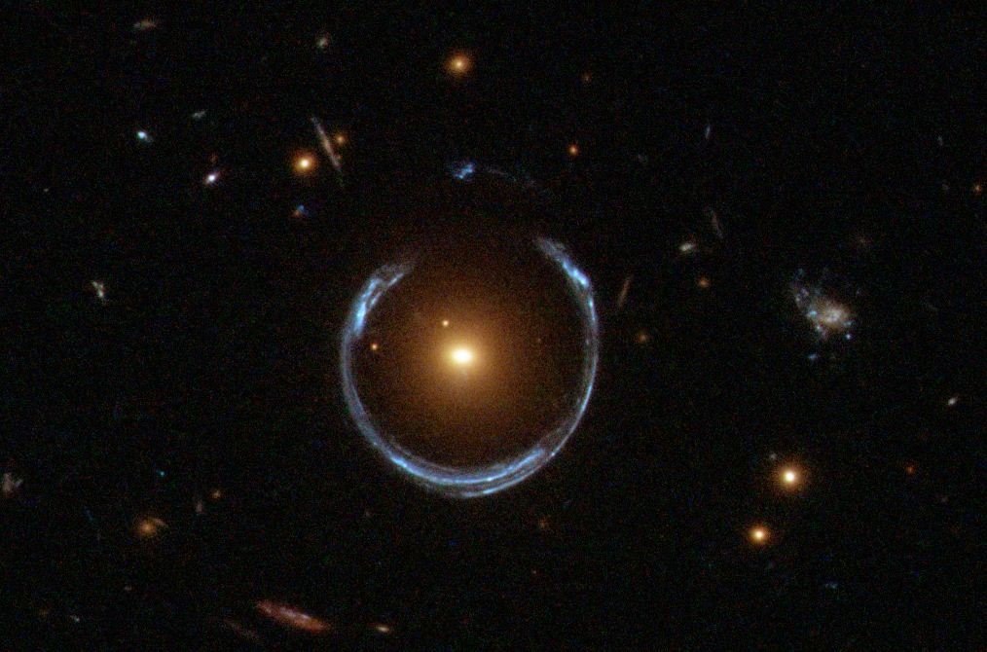
Multiple images arise from multiple paths between the source and the observer, say, in a thought experiment, light going ‘above’, ‘below’, ‘left’, and ‘right’ leading to four images. Four images is not a limiting case. Astronomers confirm the objects are the same by analyzing their spectra. When identical, the images are coming from the same source with the same composition, just taking different paths around the gravitational lens to reach our telescopes; a famous example is the "Twin Quasar" where scientists confirmed the two seemingly separate quasars were actually the same object due to their identical spectra. Strong gravitational lensing effects can produce both giant arcs and multiple images.
Figure 1 Strong Lensing (Wikipedia attribution)

Weak Lensing
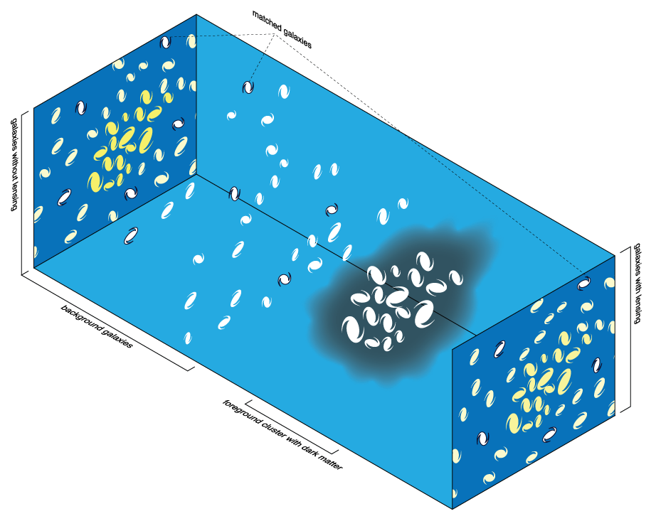
There is weak lensing from light crossing large-scale comingled distributions of matter and dark matter such as large clusters of galaxies in a blob and halo of dark matter (Figure 2).
Figure 2 Weak (statistical) lensing (Michael Schs Wikipedia Commons)
Most lines of sight in the universe between a source and an observer run through weak lensing regimes in which the deflection is impossible to detect in any single background source. Even for these weak lensing situations, the presence of the foreground mass can be detected by way of a systematic alignment of background sources around the lensing mass.

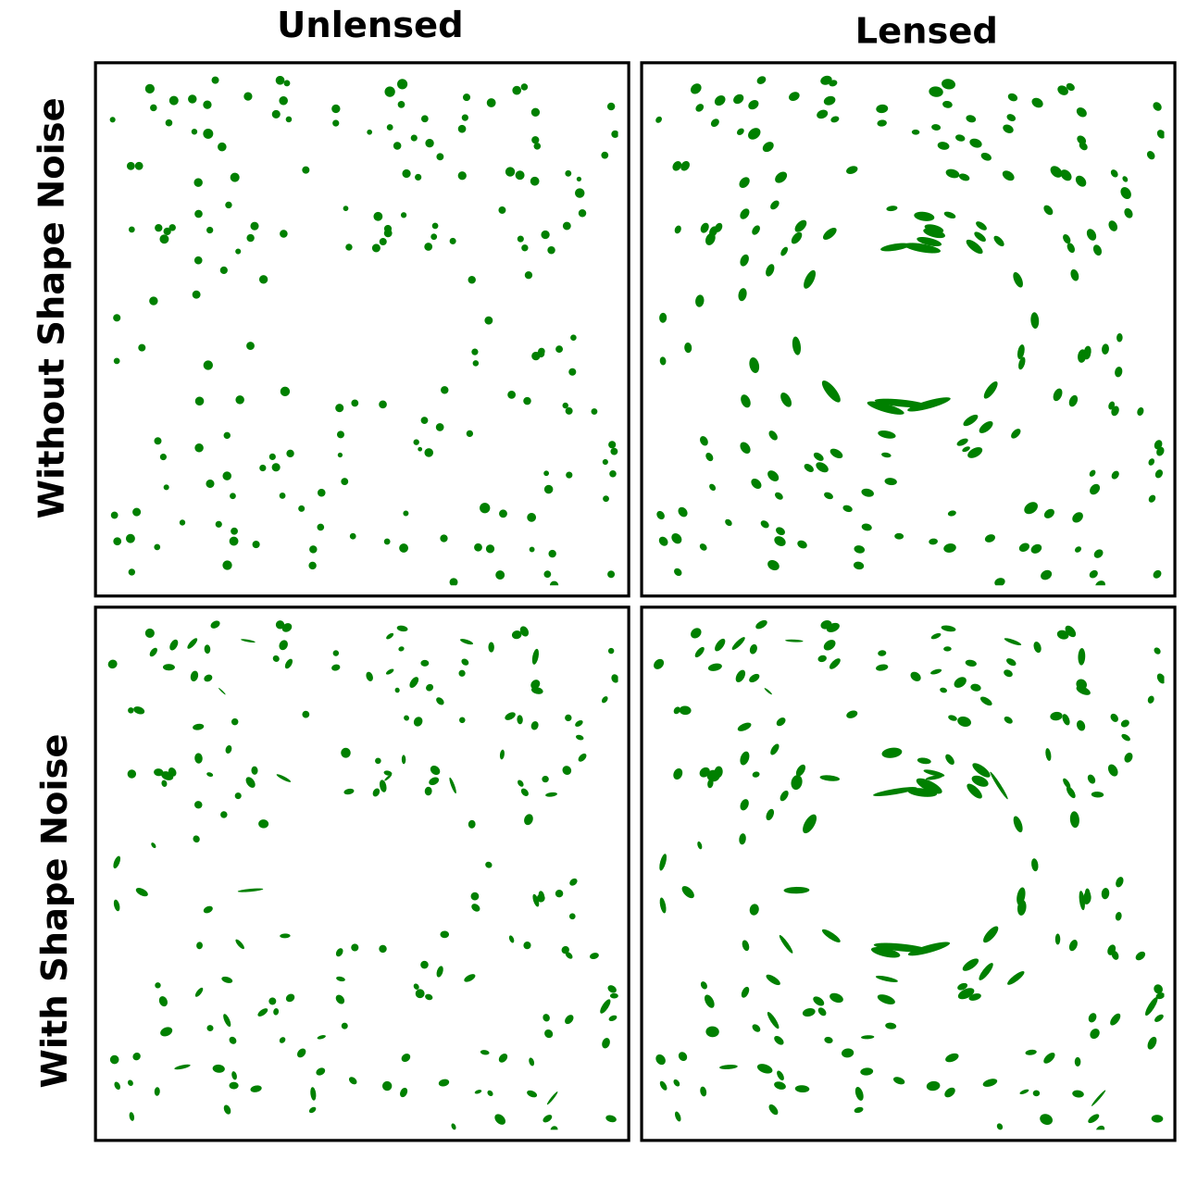
Only by analyzing the collective alignment of many background galaxies across a large area can the presence of a foreground mass be detected and quantified statistically. The signal becomes apparent after averaging over a large number of sources (often galaxies). This provides a way to measure the masses of astronomical objects (the weak lenses like the galactic clusters in Figure 2) without requiring assumptions about their composition or dynamical state (Figure 3, explained below the figure).
Figure 3 Averaging of 'shape noise' of galaxies (Wikipedia)
Weak gravitational lensing distorts the images of background objects (usually galaxies) near a foreground mass. The shape of an intrinsically elliptic galaxies can be stretched (shear), and the size of the galaxies may be magnified (convergence). Their measured ellipticity (after being lensed) is therefore a combination of their intrinsic ellipticity and the gravitational lensing shear. The intrinsic ellipticity is typically much greater than the shear (by a factor of 3-300 depending on the foreground mass). The measurements of many background galaxies must be combined to average down this "shape noise".

The orientation of intrinsic ellipticities of galaxies should be almost entirely random, so any systematic alignment between multiple galaxies can generally be assumed to be caused by lensing. There are significant complications due to atmospheric and telescope induced effects than can rival the effect of weak gravitational lensing. Care must be taken.

Observational Applications of Strong Gravitational Lensing : Time-delay Cosmography
If a strong lens produces multiple images (of pulsating sources in particular), there will be a relative time delay between two paths: that is, in one image the lensed object will be observed before the other image. The measured time delay between those images is directly related to the distance to the object and can therefore be used to calculate the Hubble constant, which represents the expansion rate of the universe at intermediate ranges; essentially, the time delay acts as a "cosmic ruler" to measure distances across the universe independent of standard candles for local scales and is independent of CMB cosmic scale methods.

Concept of Gravitational Lensing and Time Delay
When light from a distant source (e.g., a quasar or supernova) passes near a massive foreground object (e.g., a galaxy or galaxy cluster), the gravitational field of the lens bends the light, creating multiple images of the source. If the source is variable (e.g., a flickering quasar), we know that the brightness variations will appear in the different images with measurable time delays between them, but the picture is a little more complicated.

Two Reasons for Time Delays
The time delay between images arises from two effects:

Geometric Path Difference: The light paths for the different images have different lengths due to the positions of the source, lens, and observer.

Gravitational Time Dilation: The massive lens distorts spacetime, causing additional delays as light moves through stronger gravitational fields.

The total time delay $Δt$ for light from one image relative to another is given by:

$$Δt=\frac{D_{Δt}}{c}\left[\frac{1}{2}\left(θ^{2}-θ_{lens}^{2}\right)-ψ\left(θ\right)\right]$$
Where $c$ is the speed of light, and

$D_{Δt}$: The time-delay distance, which depends on cosmological parameters, including $H_{o}$,
$θ$ is the observed angular position of the image,
$θ_{lens}$ is the angular position of the lens,
$ψ\left(θ\right)$ is the gravitational potential of the lens.

Time-Delay Distance $D_{Δ_{t}}$
The time-delay distance $D_{Δ_{t}}$ is a combination of cosmological distances and is inversely proportional to $H_{o}$:
$$D_{Δ_{t}}=\left(1+z_{lens}\right)\frac{D_{lens}D_{source}}{D_{lens-source}}$$
where:

$z_{lens}$ is the redshift of the lens,
$D_{lens}$ is the angular diameter distance to the lens,
$D_{source}$ is the angular diameter distance to the source,
$D_{lens-source}$ is the agular diameter distance between the lens and the source.

This distance depends on $H_{0}$and other cosmological parameters (e.g., matter density $Ω_{m}$).

Steps to Determine $H_{o}$
To determine $H_{o}$using time-delay cosmography:

a) Observe the Time Delay: Monitor the variability of the lensed source (e.g., a flickering
quasar). Measure the time delay, $Δt$, between different images.

b) Model the Lens Mass Distribution: Use detailed lensing models to reconstruct the mass distribution of the lens. Include the positions and brightnesses of the lensed images to constrain the lens potential $ψ\left(θ\right)$.

c) Measure Redshifts: Determine the redshifts of the lens, $z_{lens}$ and the source $z_{source}$.

d) Calculate $D_{Δt}$: From the observed time delays, lens model, and redshifts, compute the time-delay distance $D_{Δt}$.

e) Extract $H_{o}$: Since $D_{Δt}$ is inversely proportional to$H_{0}$, solve for $H_{0}$using the relationship:
$$H_{o} ∝\frac{1}{D_{Δ_{t}}} .$$

5. Advantages of Time-Delay Cosmography
It is independent of Standard Candles: No need for Cepheids, Type Ia supernovae, or the cosmic distance ladder. It uses direct Measurement: Relies on general relativity and well-modeled lens systems. It provides intermediate Redshift Sensitivity. It probes the universe, that is, at redshifts ($z≈0.1 to 1.0$), filling the gap between local and CMB methods.

6. Challenges and Systematics
- Lens Mass Model Uncertainties: The accuracy of $H_{o}$ depends on precise modeling of the lensing galaxy's mass distribution.
- Mass-Sheet Degeneracy: A degeneracy between the lens mass distribution and external structures along the line of sight can introduce uncertainties.

- Microlensing and Dust: Variations caused by smaller objects in the lens or dust extinction can complicate measurements.

7. Recent Results
Time-delay cosmography has been used to measure $H_{o}$with results often close to those from local distance ladder methods. Studies such as the H0LiCOW collaboration report values of $H_{o}$∼73 km/s/Mpc, consistent with Cepheid-SNe Ia methods but higher than CMB results ($H_{o}$∼67) but is near the value derived from local, standard candle methods.

8. Resolving the Hubble Tension
By providing an independent and direct measurement of $H_{o},$time-delay cosmography could help resolve the discrepancy between local ($H_{o}$∼73) and CMB-based ($H_{o}$∼67) values. Improvements in lens modeling (e.g., through high-resolution data from JWST) and accounting for systematic effects may refine these measurements further. This is anticipated in the next few years.

Summary
Time-delay cosmography determines the Hubble constant by measuring the delays in light travel times between multiple images (different paths) of a gravitationally lensed source. These delays depend on the time-delay distance, which is inversely proportional to $H_{o}$. This method provides an independent way to measure $H_{o}$and complements other approaches, helping to address the ongoing Hubble tension between the various local and cosmological scales.

Einstein zig-zag lens (first one found in 2024)
An Einstein zig-zag lens refers to a unique configuration of gravitational lensing where light from a distant object appears to "zig-zag" as it passes through multiple galaxies. A zig-zag lens potentially allows for more accurately measures of the Hubble constant and addressing the "Hubble tension" - the discrepancy in measurements of the universe's expansion rate from different methods. Essentially, the zig-zag pattern provides a more detailed picture of the light's path than single strong gravitations lenses, leading to better calculations of cosmic expansion rates and dark energy properties (Figure 4 The first zig-zag lens). In Figure 4 The first zig-zag lens, the images $D$ (source quasar) and $F$ (first lensing galaxy) are the zig-zag images. The other images were bent only once by a single lens (a single galaxy).

Figure 4 The first zig-zag lens
The unique configuration of the first ever Einstein zig-zag lens should enable accurate measurements of the Hubble constant and assess the amount of dark energy in this area of space. Additionally, this lens can also be used simultaneously to constrain the equation of state (EOS) of dark energy of the universe. The EOS of dark matter and $H_{o}$ are typically degenerate. “With this system, we might be able to break this degeneracy", stated Martin Millon, discovery team member and a Stanford University cosmologist. “That would allow for both values to be determined simultaneously using J1721+8842, something generally not possible.”, Milton added. This is something presently in progress, but much theoretical work and technical infrastructure development are needed before the team can measure the two values they want to examine in a "safe" way, avoiding potential biases and errors.
"J1721+8842 has other applications, such as studying the more distant lensing galaxy," research lead author and EPFL Laboratory of Astrophysics scientist Frédéric Dux said. "Because it acts both as a lens and as a light source, appearing as the distorted red arc, we can precisely infer its mass. We also have a beautiful spectrum from the JWST observation to study this galaxy's star formation history and the clumpiness of its matter. This is the first real chance to answer such questions for a galaxy this far away."

Double source plane lensing (DSPL) (from a zig-zag lens) provides ratios of distances to sources and lenses, adding independent constraints on cosmological parameters. It breaks the Mass-Sheet Degeneracy: A key uncertainty in lensing measurements is the mass-sheet degeneracy, where mass distributions along the line of sight affect results.

Observational applications of Weak gravitational lensing
Analyzing the distortions caused by weak gravitational lensing, astronomers can infer the distribution of dark matter in galaxy clusters, and also characterize the equation of state (EOS) for dark matter.

Dark Matter EOS improvements for better measurements of $H_{o}$ and better understaning of dark matter
The EOS for dark matter describes the relationship between its pressure ($P$) and energy density ($ρ$). It is a way of characterizing how dark matter behaves dynamically and interacts with its environment, which in turn influences the structure and evolution of the universe.

General Form of the Equation of State
The equation of state is often expressed as:
$$P=wρc^{2}$$

where: $c$ is the speed of light,
$P$is the pressure,
$ρ$ is the energy density,
$w$ is the EOS parameter which characterizes the nature of the material or energy

For dark matter, $w≈0.$ This means: Negligible Pressure: Dark matter exerts almost no pressure compared to its energy density and Non-Relativistic Behavior. Dark matter behaves like "cold" matter (slow-moving), rather than "hot" relativistic particles (like photons or neutrinos). This assumption aligns with the Cold Dark Matter (CDM) model, where dark matter is treated as a pressureless fluid.

Why $w≈0$?

1. Non-Thermal Origin: Dark matter particles likely do not have significant thermal motion, unlike matter or radiation, which can have significant pressure.

2. Weak Interactions: Dark matter interacts very weakly (or not at all) with electromagnetic forces, meaning it does not generate pressure through radiation or thermal processes.

3. Gravitational Clumping: Since dark matter has no significant pressure to counteract gravitational forces, e.g., radiation pressure from stars, it clumps together, forming the scaffolding for galaxies and large-scale structures.

Implications of the EOS for Dark Matter
Cosmic Structure Formation: Pressureless dark matter allows small density fluctuations in the early universe to grow under gravity, leading to the formation of galaxies, galaxy clusters, and cosmic filaments.

Expansion of the Universe: With $w≈0$, dark matter does not contribute significantly to the pressure component in the univers’s energy budget, affecting its expansion differently than dark energy (for which $w≈-1$). This is repulsive outward pressure.

Alternative EOS for Dark Matter
While $w≈0$ applies to cold dark matter, alternative models explore other values of $w$, depending on the properties of dark matter:

Warm dark matter: If dark matter particles are lighter and move faster, they might exert slight pressure, giving $w>0$.

Self-interacting Dark Matter: If dark matter particles interact with one another, this could lead to a small pressure, also giving $w>0$.

These models are studied to address unresolved CDM simulation issues or the core-cup problem.

Comparison with Dark Energy
Dark energy, the force driving the accelerated expansion of the universe, has an EOS parameter $w=-1$. This negative $w$ corresponds to a replusive pressure that dominates over the gravitational pull of matter.

The Cosmic Scale Rung of the Cosmic Distance Ladder – the Cosmic Microwave Background (CMB)
Understanding the CMB: The CMB is the thermal radiation left over from the time when the universe became transparent (~380,000 years after the Big Bang, during the epoch of recombination). It provides a "snapshot" of the early universe, encoding information about its geometry, composition, and dynamics. The CMB method for measuring the Hubble constant $H_{0}$ involves the analysis of the anisotropies in the CMB radiation, the relic radiation from the Big Bang.

Angular Power Spectrum of the CMB
The CMB anisotropies are studied using their angular power spectrum, $C_{l}$, which quantifies fluctuations as a function of angular scale (ℓ is the multipole moment). Here are the key scales in the CMB power spectrum:
- Acoustic peaks: Arise from sound waves in the photon-baryon plasma before recombination.
- Damping tail: Caused by Silk damping, where small-scale fluctuations are suppressed due to photon diffusion.

Physics of the Acoustic Peaks
The location and height of these peaks depend on:

1. Sound horizon ($r_{s}$): The maximum distance sound waves could travel before recombination, determined by the speed of sound in the photon-baryon plasma:
$$r_{s}=\int_{0}^{∞ }{c_{x}\left(t\right)\frac{dt}{a\left(t\right)}}$$
where:
$$c_{s}= \frac{c}{\sqrt{3\left(1+R\right)}},$$
and
$$R=\frac{3ρ_{0}}{4ρ_{γ}}$$
is the baryon-to-baryon density ratio, and $a\left(t\right)$ is the scale factor.

2. Angular diameter distance to the CMB ($D_{A}$): The angular scale ($θ$) of a feature in the CMB relates to its physical size ($r_{s}$) and distance ($D_{A}$) as: $Θ∼{r_{s}}/{D_{A}}.$ $D_{A}$ depends on the Hubble constant and the composition of the universe (dark matter, dark energy, baryons):

$$D_{A}=\frac{1}{1+z_{rec}}\int_{o}^{∞}{\frac{cdz}{H\left(z\right)}},$$
where $H\left(z\right)$ is the Hubble parameter:

$$H\left(z\right)=H_{0}\sqrt{Ω_{m}{\left(1+z\right)}^{3}+Ω_{r}{\left(1+z\right)}^{4}+Ω_{Λ}.}$$

How $H_{0}$ is Measured:
The CMB method measures $r_{s}$ and $D_{A}$, both of which depend on the cosmological parameters, including $H_{0}$, $Ω_{m}$ (matter density), $Ω_{Λ}$ (dark energy density), and $Ω_{B}$ (baryon density). By fitting the observed CMB power spectrum with theoretical models, cosmologists infer $H_{0}$ alongside other parameters using Bayesian statistics.

Degeneracies and Constraints:
The CMB method doesn’t measure $H_{0}$ directly but constrains it with a combination of parameters which introduce degeneracies, e.g., between $H_{o}$ and $Ω_{Λ}$.
Combining CMB data with other observations (e.g., baryon acoustic oscillations, supernovae) breaks these degeneracies, providing a more precise $H_{o}$. The Einstein zig-zag lens could also break degeneracies.

Role of Inflation and Initial Conditions:
The physics of inflation determines the initial conditions for density perturbations, which seed the CMB anisotropies. The spectrum of these perturbations, described by the scalar spectral index $n_{s}$, influences the inferred $H_{o}$.

Current Tensions:
Measurements of $H_{o}$from the CMB (e.g., by the Planck satellite) typically give lower values (e.g., $H_{o}$∼67.4 km/s/Mpc) than those from local universe measurements (e.g., supernovae and Cepheids, $H_{o}$∼73 km/s/Mpc). This tension, known as the Hubble tension, suggests either unknown systematic errors or new physics beyond the standard $Λ$CDM model.

By analyzing the CMB anisotropies, cosmologists constrain $H_{0}$ within the broader framework of the universe's evolution and composition.

What Causes the Hubble Tension?
The exact source of the Hubble tension is still debated, and several possibilities are being explored. Issues like assumptions about the sound horizon scale in CMB analysis could play a role. Perhaps its due to unknown systematic errors. Despite JWST’s confirmation, there could still be undiscovered systematic errors in either the Cepheid-based distance ladder or the CMB analysis. Perhaps it is new physics beyond the $Λ$CDM, say, Early Dark Energy, a form of dark energy active in the early universe could alter the expansion rate. It is possible that we may have to develop a modified theory of gravity, e.g., Modified Newtonian Dynamics (MOND), that might affect large-scale structure formation and the inferred $H_{0}$. Perhaps there are extra-relativistic particles, so-called “Dark radiation” or additional neutrino species that could impact the CMB-based $H_{0}$ calculations.

Resolving the tension is critical for understanding the universe’s expansion and could lead to transformative insights into cosmology and/or particles and fields.

Appendix A: Sample Rosseland Opacity Calculation
Working through an example calculation using the Rosseland mean opacity, a weighted average opacity used to describe how radiation diffuses through a medium in stellar interiors or other high-temperature plasmas.

Problem Statement: You are tasked with calculating the Rosseland mean opacity ($κ_{R}$) for a plasma in a star where the opacity at different wavelengths ($κ_{ν}$) and the derivative of the Planck function (${∂B_{ν}}/{∂T}$) are known for three representative wavelengths.

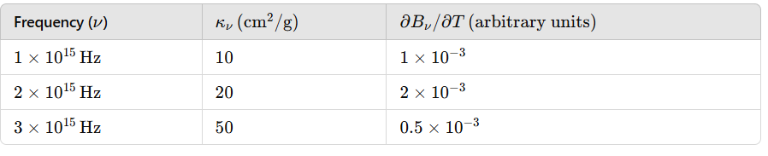
Given Data: At a temperature T=10,000 K, the following data is available for three wavelength bands ($ν_{1}, ν_{2}, ν_{3}$):

The Rosseland mean opacity is given by:

$$\frac{1}{κ_{R}}=\frac{\int_{0}^{∞}{\frac{1}{κ_{ν}}∙\frac{∂B_{ν}}{∂T}}dν}{\int_{0}^{∞}{\frac{∂B_{ν}}{∂T}}dν}$$
- where:
- $κ_{ν}$: is the opacity at frequency $ν$,
- $B_{ν}$: Is the Planck (blackbody radiation) function, and
- $T$: Is the temperature.

For discrete frequencies, this becomes:
$$\frac{1}{κ_{R}}=\frac{\sum_{i}{\frac{1}{k_{ν_{i}}}}∙\frac{∂B_{ν_{i}}}{∂T}}{\sum_{i}{\frac{∂B_{ν_{i}}}{∂T}}}$$

Step 1: Compute $1/{k_{ν}}$ for each frequency:

$$\frac{1}{κ_{ν_{1}}}=\frac{1}{10}=0.1, \frac{1}{κ_{ν_{2}}}=\frac{1}{20}=0.2, \frac{1}{κ_{ν_{3}}}=\frac{1}{50}=0.02$$
Step 2: Multiply by ${∂B_{ν}}/{∂T}$ for each frequency:

$$\frac{1}{κ_{ν_{1}}}∙\frac{∂B_{ν_{i}}}{∂T}=0.1∙\left(1×{10}^{-3}\right)=1×{10}^{-4}$$
$$\frac{1}{κ_{ν_{2}}}∙\frac{∂B_{ν_{2}}}{∂T}=0.05∙\left(2×{10}^{-3}\right)=1×{10}^{-4}$$

$$\frac{1}{κ_{ν_{3}}}∙\frac{∂B_{ν_{3}}}{∂T}=0.02∙\left(0.5×{10}^{-3}\right)=1×{10}^{-5}$$

Step 3: Compute the sum:

$$\sum_{i}{\frac{1}{k_{ν_{i}}}}∙\frac{∂B_{ν_{i}}}{∂T}=\left(1×{10}^{-4}\right)+\left(1×{10}^{-4}\right)+\left(1×{10}^{-5}\right)=2.1×{10}^{-4}$$

Step 4: Compute the Sum

$$\sum_{i}{\frac{∂B_{ν_{i}}}{∂T}}=\left(1×{10}^{-3}\right)+\left(1×{10}^{-3}\right)+\left(1×{10}^{-3}\right)=3.5×{10}^{-3}$$

Step 5: Compute
$$\frac{1}{κ_{R}}=\frac{\sum_{i}{\frac{1}{k_{ν_{i}}}}∙\frac{∂B_{ν_{i}}}{∂T}}{\sum_{i}{\frac{∂B_{ν_{i}}}{∂T}}}=\frac{2.1×{10}^{-4}}{3.5×{10}^{-3}}=0.06$$

Step 6: Compute $κ_{R}$
$$κ_{R}=\frac{1}{0.06}=16.67 cm^{2}/g$$

Interpretation:
The Rosseland mean opacity ($κ_{R}$) averages the opacity over all wavelengths, weighted by how effectively energy is transported at each wavelength.

It emphasizes regions where radiation flows most easily, making it a practical tool for modeling energy transport in stars or hot plasmas.

Appendix B: Cepheid Variable Luminosity in More Detail
The luminosity periodicity of Cepheid variables is driven by a combination of stellar structure and thermonuclear physics, particularly the Eddington valve mechanism, also known as the κ (kappa) mechanism. Here's a detailed breakdown of how thermonuclear processes and stellar physics produce this periodicity:

Ionization Zones in the Stellar Envelope
The key to understanding Cepheid variability lies in the partially ionized zones of helium within the star's outer layers:

Helium Ionization Zones:
- First Ionization Zone: Where helium is ionized from He to He+ (losing one electron).
- Second Ionization Zone: Where helium is ionized from He+ to He2+ (losing a second electron).

These ionization zones are located in the star’s outer envelope, and their behavior is crucial for driving pulsations.

The κ Mechanism (Eddington Valve)
The κ mechanism is a thermodynamic process that amplifies oscillations in the star's luminosity:

Opacity Increases During Compression:
- When the star's outer layers are compressed, the helium ionization zones become denser and hotter.
- In these conditions, the partially ionized helium absorbs more photons (increased opacity, $κ$, trapping radiation.
- This trapped radiation leads to an increase in pressure, causing the outer layers to expand.

Opacity Decreases During Expansion:
- As the star's outer layers expand, the helium ionization zones cool and become less dense.
- The helium becomes more fully ionized, reducing opacity, allowing radiation to escape.
- This reduction in pressure causes the outer layers to contract again.
This cycle of compression (opacity increase) and expansion (opacity decrease) drives the star’s periodic pulsations, resulting in a regular variation in radius, temperature, and luminosity.

Thermonuclear Energy and Stability
The energy powering Cepheid variables comes from thermonuclear fusion in the star's core:

Fusion Processes:
Cepheids are typically massive stars (4–20 solar masses) that have exhausted hydrogen thermonuclear fuel in their cores. They are burning (fusing) helium or heavier elements (like carbon or oxygen) in shell-burning processes around the inert core. The intense energy output from these thermonuclear fusion reactions maintains the star's overall structure and drives the dynamics of the envelope.

Equilibrium Instability:
Cepheids exist in a specific evolutionary phase (crossing the instability strip on the Hertzsprung-Russel diagram. Their internal structure and energy flow are finely balanced, making them prone to the $κ$ mechanism.

Mass, Radius, Temperature, and Luminosity Periodicity
The star's pulsation period depends on its mass, radius, and luminosity, which are all related to its thermonuclear processes:

Mass and Radius: Larger, more massive Cepheids have longer periods because their larger envelopes take more time to oscillate.

Temperature: The location of the helium ionization zones depends on the star’s temperature, influencing the amplitude and regularity of pulsations.

Luminosity and Period-Luminosity Relationship:
More luminous Cepheids are generally larger and pulsate more slowly, leading to the well-known Period-Luminosity (P-L) relationship (the logarithmic relationship).

Thermodynamics of the Envelope
The detailed thermodynamics of the envelope includes:

Adiabatic (without flow of energy in or out) Compression and Expansion: During compression, the temperature increases, ionization levels change, and radiation is trapped.
Energy Transport: Radiative and convective energy transport within the star’s envelope regulates the pulsation amplitude.

Feedback Mechanisms: The $κ$ mechanism works as a feedback loop, amplifying or damping oscillations until a stable pulsation is achieved.

Interaction with the Thermonuclear Core
The periodicity of Cepheid variables is driven by the interaction between thermonuclear energy production in the core (or a shell above it if the core has run out fuel) and the dynamic response of the partially ionized helium layers in the star’s envelope. The κ mechanism governs the pulsations by cyclically trapping and releasing radiation, while the star’s mass, radius, and thermonuclear fusion processes determine the specific period and luminosity of the pulsations. This elegant coupling of nuclear physics and stellar dynamics makes Cepheids reliable standard candles in astronomy.

Appendix C: The Hertzsprung-Russel Diagram
The Hertzsprung-Russell (H-R) Diagram (Figure 5 Herzsprung-Russel Diagram) plots stars according to their luminosity (or absolute magnitude) and surface temperature (or spectral type). It is used to study the life cycles of stars, their physical properties, and their evolution.

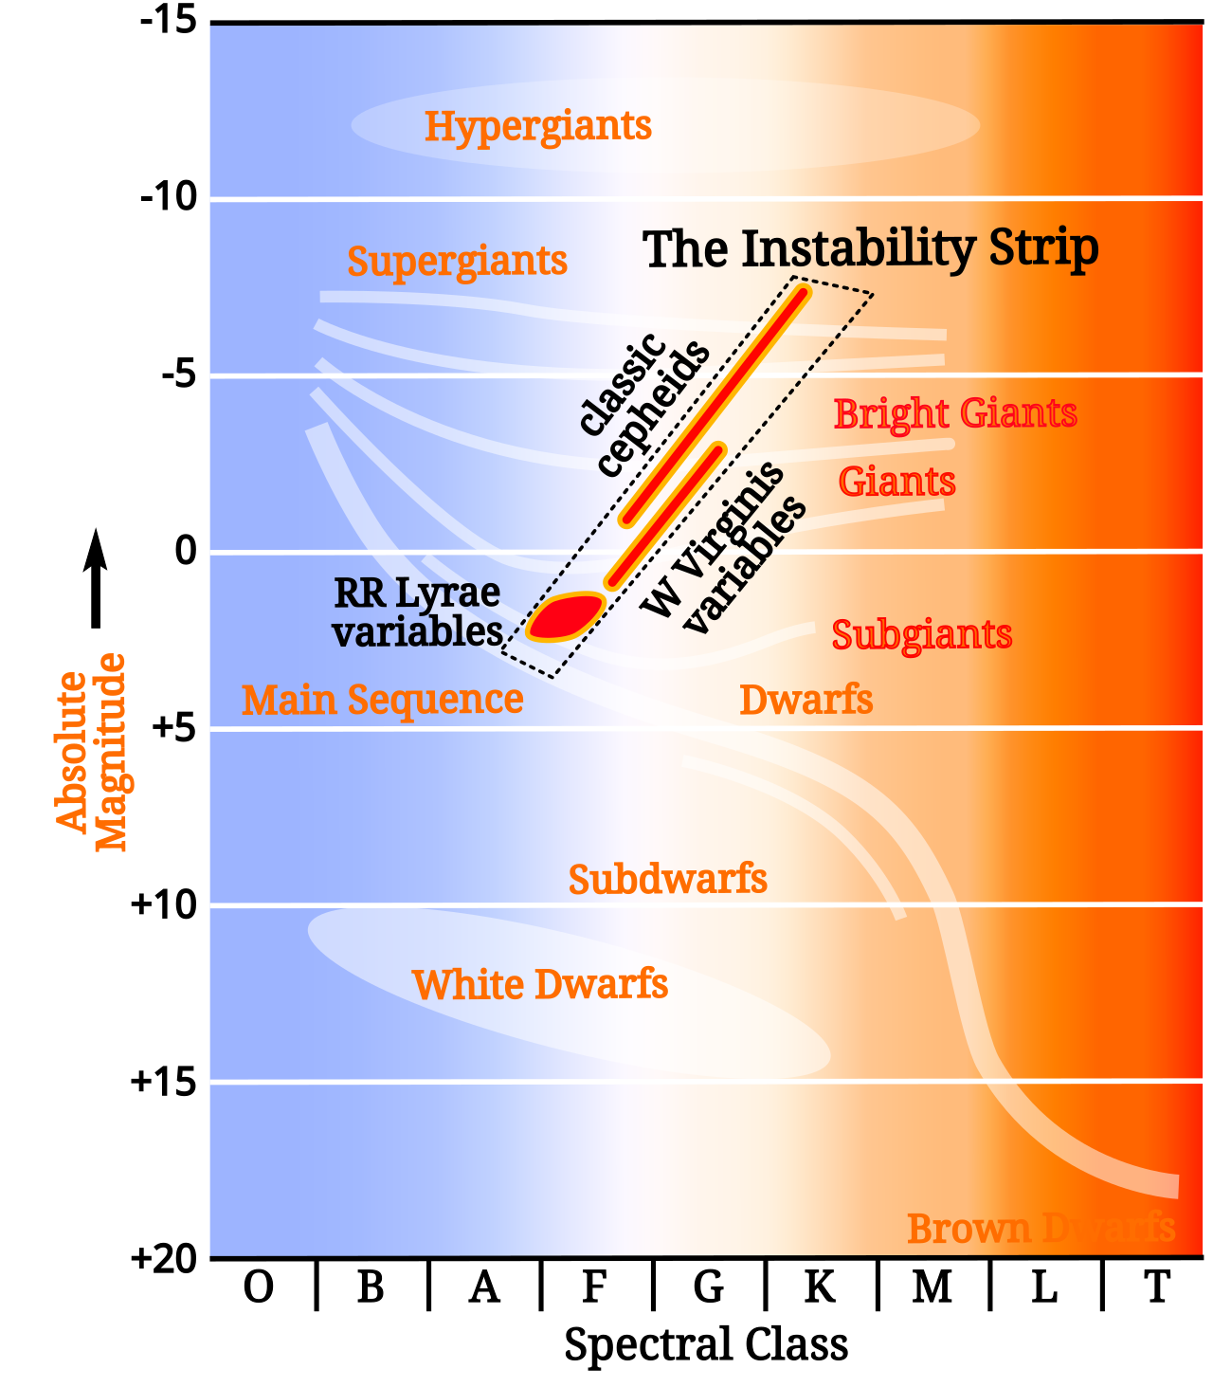
Axes of the Diagram
Figure 5 Herzsprung-Russel Diagram
The Horizontal Axis (Temperature or Spectral Type):
The temperature decreases from left to right (unlike typical graphs) along the horizontal axis. A star’s color, or spectral type, determines its temperature:
- Blue/Hot Stars: Found on the left (temperature T>10,000 K).
- Red/Cool Stars: Found on the right (temperature T<3,500 K).
Spectral types are classified as O, B, A, F, G, K, M with O being the hottest and M the coolest.

The Vertical Axis (Luminosity or Absolute Magnitude):
Luminosity is plotted on a logarithmic scale, of relative the luminosity of the sun, $L_{⊙}$. Brighter stars are higher on the diagram, while dimmer stars are lower.

Main Features of the Diagram
The H-R Diagram can be divided into several key regions, corresponding to different types of stars:

a) Main Sequence:
- A diagonal band running from the top left (hot, luminous stars) to the bottom right (cool, dim stars).
- Represents stars in the hydrogen-burning phase of their life.
- Example: The Sun is a main sequence star of spectral type GG.

b) Giants and Supergiants: Located above the main sequence:
- Red Giants: Luminous but cool stars in the later stages of stellar evolution.
- Supergiants: Extremely luminous stars with large radii, often found near the top of the diagram.
These stars have exhausted hydrogen in their cores and are burning heavier elements.

c) White Dwarfs: Found in the lower-left corner of the diagram:
- Hot but very dim stars.
- They are the remnants of stars that have shed their outer layers and no longer undergo fusion.

How Stars Evolve on the H-R Diagram
The H-R Diagram shows how a star’s position changes as it evolves:

Formation and Main Sequence:
- Stars form from collapsing clouds of gas and dust.
- They enter the main sequence when hydrogen fusion ignites in their cores.
Post-Main Sequence Evolution:
- Low-Mass Stars: Expand into red giants after exhausting core hydrogen. Shed outer layers to form planetary nebulae, leaving behind a white dwarf.
- High-Mass Stars: Expand into supergiants and may end their lives in supernova explosions, leaving neutron stars or black holes.

Applications of the H-R Diagram
- Stellar Classification: Provides a visual way to classify stars by temperature and luminosity.
- Distance Estimation: For clusters, the diagram helps estimate distances via main-sequence fitting.
- Age Determination: The position of the main sequence turnoff (where stars leave the main sequence) indicates the age of a star cluster.
- Stellar Evolution Studies: Tracks the life cycles of stars and reveals patterns in their development.

Simplified Example
The Sun ($t≈5,800 K, L=L_{⊙}$, in the middle of the main sequence) is a G2V star, also known as a yellow dwarf star. That is, the sun is:
- G: A G-type star, which means it's a yellow star with a prominent band of atomic and molecular spectral lines.
- 2: More specifically, a G2 star, meaning it's one of the second hottest stars in the G class.
- V: Yet more specifically, the Sun is a V star, which means it's a main sequence, or dwarf, star.
The sun is a G2V star.

Sirius A ($T≈10,000 K, L=25L_{⊙}, M≈2M_{⊙}$, upper left of the main sequence) is a type A star, A0 or A1. At 8.6 light-years from Earth, it outputs 26 times more energy than the sun. It is in a binary system with Sirius B.

Sirius B ($T≈10,000 K, L=25L_{⊙}, M≈M_{⊙}$) is a type DA2 star roughly the size of Earth. Alas, the distance between Sirius A and B is between 8 and 31.5 AU and even when Sirius A becomes a red giant it will be still above 6 AU. Such distance is too large and does not allow Sirius B to accrete significant mass. Almost all mass lost by Sirius A will be as a red giant. Sirius B may become a recurrent nova due to some accretion but will not gain enough mass to explode as supernova, it will hardly gain even 0.05-0.1 solar masses.

Betelgeuse ($T≈3,500 K, L=100,000L_{⊙}$, upper right of the main sequence) is a type M1-M2 Ia-ab star. It is easily visible in the night sky due to its apparent brightness and reddish color, and is considered a semi-regular variable star, meaning its brightness fluctuates periodically. Betelgeuse, typically, has a 400-day cycle as well as a longer cycle that stretches about 5 years. By analyzing data from observatories including NASA's Hubble Space Telescope, scientists found that Betelgeuse "blew its top" in 2019. The star spewed a giant piece of its surface material out into space (a type of event known as a surface mass ejection). Once in space, this material cooled into a dust cloud that temporarily blocked the light from the star.
Ejecting material is fairly normal for stars. In fact, our Sun does this routinely, blowing out material from its outer atmosphere, or corona, in events called coronal mass ejections.

Summary
The Hertzsprung-Russell Diagram provides a powerful visual framework for understanding stars' properties and evolutionary paths. By plotting temperature and luminosity, it reveals patterns and trends, from the stable hydrogen-burning stars on the main sequence to the exotic remnants of stellar evolution, such as white dwarfs. This diagram is foundational to modern astrophysics.

Appendix D: All Supernova Types
Supernovae are broadly classified into two major categories based on their progenitor systems and the mechanisms of explosion: core-collapse supernovae and thermonuclear supernovae. These are further divided into subtypes based on their spectra and light curves. Here's a detailed overview:

1. Core-Collapse Supernovae (Massive Stars)
Core-collapse supernovae result from the collapse of the core of a massive star (>8 $M_{⨀}$) after it exhausts its nuclear fuel. They are subdivided based on the presence or absence of specific elements in their spectra:

a) Type II Supernovae
- Definition: These retain their hydrogen envelope, so their spectra exhibit prominent hydrogen lines.
- Subtypes:
  - Type II-P: Show a "plateau" in their light curve due to a prolonged period of constant luminosity.
  - Type II-L: Exhibit a linear decline in brightness after the peak.
  - Type II-n: Display narrow hydrogen emission lines, likely caused by interaction with dense circumstellar material.
  - Type IIn-P: Show narrow lines with a plateau light curve.

b) Type Ib Supernovae
- Definition: Massive stars that have lost most or all of their hydrogen envelope before exploding. Spectra show helium lines but no hydrogen lines.
- Progenitor: Likely Wolf-Rayet stars or stars stripped in binary systems.

c) Type Ic Supernovae
- Definition: Massive stars that have lost both their hydrogen and helium envelopes. Spectra lack both hydrogen and helium lines.
- Progenitor: Wolf-Rayet stars or similar progenitors with extreme mass loss.

2. Thermonuclear Supernovae (White Dwarfs)
Thermonuclear supernovae occur in compact stars like white dwarfs, typically in binary systems. The explosion is driven by runaway nuclear fusion, not core collapse.

a) Type Ia Supernovae
- Definition: The thermonuclear explosion of a white dwarf that has accreted matter from a companion star and approached the Chandrasekhar limit (∼1.4 $M_{⨀}$).
- Spectra: Lack hydrogen lines but show silicon lines at early stages.
- Progenitor System:
  - Single-Degenerate Model: White dwarf accretes material from a companion star.
  - Double-Degenerate Model: Two merging white dwarfs lead to the explosion.
- Importance: Used as standard candles in cosmology to measure distances and the expansion of the universe.

3. Rare and Exotic Supernovae
In addition to the core-collapse and thermonuclear categories, there are several rare types of supernovae with unique characteristics:

a) Type Iax Supernovae
- Definition: A fainter subtype of Type Ia, possibly due to a partial thermonuclear explosion of a white dwarf.
- Progenitor: Likely a single-degenerate system.
- Importance: Their low luminosity makes them harder to detect.

b) Pair-Instability Supernovae
- Definition: Extremely massive stars (>100$M_{⨀}$) undergo pair production in their cores, reducing radiation pressure and triggering collapse followed by a thermonuclear explosion.
- Outcome: Completely disrupts the star, leaving no remnant.

c) Electron-Capture Supernovae
- Definition: Occur in stars with initial masses of ∼8–10 $M_{⨀}$, where the core collapses due to the capture of electrons by nuclei (e.g., magnesium-24).
- Progenitor: Stars at the lower end of the mass range for core-collapse supernovae.

d) Superluminous Supernovae (SLSNe)
- Definition: Exceptionally bright supernovae (10–100 times brighter than normal).
- Subtypes:
  - SLSN-I: Hydrogen-poor, potentially powered by a magnetar (a rapidly rotating neutron star).
  - SLSN-II: Hydrogen-rich, possibly powered by interaction with circumstellar material.

e) Hypernovae
- Definition: Extremely energetic core-collapse supernovae associated with long-duration gamma-ray bursts (GRBs).
- Progenitor: Likely massive, fast-rotating stars with strong magnetic fields.

4. Summary of Supernova Types
Category | Subtype | Key Features | Progenitor
Core-Collapse | Type II (II-P, II-L, IIn) | Hydrogen lines, massive stars with envelopes | Massive stars (>8 $M_{⨀}$)
 | Type Ib | No hydrogen, helium lines present | Stripped massive stars
 | Type Ic | No hydrogen or helium lines | Heavily stripped massive stars
Thermonuclear | Type Ia | No hydrogen, silicon lines, white dwarf explosion | White dwarf in binary system
Rare Types | Type Iax | Faint thermonuclear explosion | White dwarf in binary system
 | Pair-Instability | Explosion of extremely massive star | >100M⊙ > 100 $M_{⨀}$ stars
 | Electron-Capture | Collapse triggered by electron capture | 8–10M⊙ 8–10 $M_{⨀}$ stars
 | Superluminous (SLSN-I, II) | Extremely bright | Varies: magnetars or interaction
 | Hypernova | Very energetic, associated with GRBs | Massive, fast-rotating stars

Final Notes
The diversity of supernovae reflects the variety of stellar systems and physical processes at play in the universe. Each type provides unique insights into stellar evolution, nucleosynthesis, and cosmology, making them key to understanding the cosmos.

Appendix E: Observational Limits in terms of Redshifts, $z$
Can We Observe Objects with Redshift z=1 with the Naked Eye? No, there are no objects with a redshift of z=1 that are visible to the naked eye. Objects at such a redshift are extremely distant, faint, and significantly redshifted into the infrared or far optical wavelengths, well beyond the capability of unaided human vision.

Objects with a redshift of z=1 are approximately 8 billion light-years away (depending on the exact cosmological model). At this distance, the apparent brightness (even the brightest galaxies or quasars) is too faint for the naked eye. Due to the cosmological redshift, the light is stretched into the red or infrared part of the spectrum, which is harder for the human eye to detect.

For context, the farthest objects visible to the naked eye are: The Andromeda Galaxy (M31), at about z∼−0.001 (blueshifted, ~2.5 million light-years away). Bright stars or nebulae within the Milky Way, at distances of a few thousand light-years.

What Telescope is Needed to Observe z=1 Objects? To observe objects with z=1, such as distant galaxies or quasars, you need a telescope with:
- Significant Light-Gathering Power: Large aperture to detect faint objects.
- Spectroscopic Capabilities: To confirm redshift measurements.
- Telescope Requirements:
  - Amateur Telescopes: A good amateur telescope (8-inch to 12-inch aperture) can detect some bright quasars with z ∼ 1, such as 3C 273 (the brightest quasar in the sky, z=0.158).
  - Professional Telescopes: For the majority of z=1 objects:
    - Ground-based observatories with 8-meter to 10-meter class telescopes (e.g., Keck Observatory, Very Large Telescope).
    - Space-based observatories like the Hubble Space Telescope (HST) or the James Webb Space Telescope (JWST) for detailed imaging and spectroscopy.

Hubble Versus James Webb Space Telescope
The HST has made significant contributions to our understanding of the early universe by identifying some of the most distant galaxies known. One notable discovery is GN-z11, a galaxy with a spectroscopically confirmed redshift of 11.1, placing it approximately 13.4 billion years in the past, just 400 million years after the Big Bang. Another significant finding is UDFj-39546284, initially estimated to have a redshift of 11.9, suggesting it existed about 13.42 billion years ago. However, subsequent observations have led to debates regarding its exact redshift, with some studies proposing it might be a lower-redshift interloper.

These discoveries have been instrumental in advancing our knowledge of galaxy formation and evolution in the early universe. They also highlight the challenges in confirming such high-redshift objects, emphasizing the need for precise spectroscopic measurements to validate their distances.

It's important to note that while HST has identified galaxies at these extreme distances, as of May 2024 the JWST has surpassed these records, detecting galaxies with redshifts as high as 14.32, corresponding to a time just 290 million years after the Big Bang. This underscores the rapid advancements in observational astronomy, continually pushing the boundaries of our cosmic horizon. This places the galaxy's formation approximately 290 million years after the Big Bang, offering unprecedented insights into the early universe.

The discovery was part of the JWST Advanced Deep Extragalactic Survey (JADES), utilizing JWST's Near-Infrared Spectrograph (NIRSpec) for spectroscopic confirmation. This finding surpasses previous records, such as JADES-GS-z13-0 at redshift 13.2, and highlights JWST's capability to explore the universe's formative epochs.

These observations challenge existing models of early galaxy formation, suggesting that galaxies may have formed, grown, and evolved faster than previously thought. The detection of such high-redshift galaxies indicates that the early universe was more complex and dynamic, prompting a reevaluation of theories regarding the timeline of cosmic evolution.

In summary, JWST's detection of JADES-GS-z14-0 at redshift 14.32 marks a significant advancement in our understanding of the early universe, providing a glimpse into galaxy formation just a few hundred million years after the Big Bang.

Hubble trouble or Superbubble? Astronomers need to escape the ‘supervoid’ to solve cosmology crisis, Robert Lea, 18 Dec 2024, Space.com
Dark energy ‘doesn’t exist’ so can’t be pushing ‘lumpy’ universe apart, physicists say, 20 Dec 2024, Royal Astronomy Society
JWST validates HST Distance Measurements: Selection of Supernova Subsample Explains Differences in JWST Estimates of local $H_{0}$, A. D. Riess et al, 29 Oct 2024, arXiv:2408.11770v2
Reevaluating $H_{o}$ Tension with Non-Planck CMB and DESI BAO Joint Analysis, Ye-Huang Pang et al, 21 Nov 2024, arXiv:2411.14189v1
Observations of a new variable star. In a letter from Edward Pigott, Esq. to Sir. H. C. Englefield, Bart. F.R.S. and A.S, Philosophical Transactions of the Royal Society. 1785, 75: 127–136.
A series of observations on, and a discovery of, the period of the variation of the light of the star marked δ by Bayer, near the head of Cepheus. In a letter from John Goodricke, Esq. to Nevil Maskelyne, D.D.F.R.S. and Astronomer Royal, 1786 Philosophical Transactions of the Royal Society of London. 76: 48–61.
Periods of 25 variable stars in the Small Magellanic Cloud", Leavitt, Henrietta S.; Pickering, Edward C., 1912, Harvard College Observatory Circular. 173: 1–3.
J1721+8842: The first Einstein zig-zag lens, F. Dux, M. Milton, et al, 6 Nov 2024, arXiv:2411.04177v1
Ibid.
James Webb Space Telescope spots 1st ‘Einstein zig-zag’ – here’s why scientists are thrilled, R. Lea, 21 Nov 2024, Space.com
Ibid.

